
Info texts and graphic material on i-konf
The following texts and graphics can be used freely, for example for newsletters, homepages etc. The target group is pastors and others persons responsible for confirmation work. If you need further material, please contact Manuela Hees and the i-konf team at info@konfirmandenarbeit.eu

Mini note (455 characters)
The perspective of the participating young people is crucial for the further development of confirmation work. With the feedback tool "i-konf", parishes can conduct a survey of their confirmands easily and free of charge. Customisable standard questionnaires are available at www.i-konf.eu. The confirmands can fill them out on their mobile phones or on paper. The evaluation is available immediately afterwards. For background information see www.konfirmandenarbeit.eu.

Short text (895 characters)
Feedback-Tool i-konf
What do young people think about their confirmation time? This question is crucial for all who want to further develop confirmation work in a subject-oriented way. They now can use the interactive feedback tool "i-konf". The free online application was developed in an international research project and offers the possibility to conduct an individualised survey on site.
No installation is required; any internet-ready device can be used. After registering at www.i-konf.eu, a standardised survey is selected and adapted to one's own needs. The survey is sent to the confirmands via a link or QR code. They fill out the questionnaire on their mobile phones within 10 minutes. Immediately afterwards, the person in charge can download the results as graphics or tables.
Working with i-konf is easy! Step-by-step instructions and video tutorials are provided at www.i-konf.eu/en/help.

Longer text (1695 characters)
Obtain feedback from the conferees using the online tool i-konf
What do young people think about their confirmation time? What are they satisfied with? What could be improved? What topics would they like to be included? Such questions are crucial if you want to develop confirmation work in a subject-oriented way. With the online tool "i-konf" you can now obtain the feedback of your confirmation work. This free online application for congregations was developed in the context of international studies on confirmation work.

No installation is required; any internet-ready device can be used. At www.i-konf.eu a standardised questionnaire is selected and adapted according to your own needs. Existing questions can be deleted and your own questions added. There are also a number of additional modules with a special thematic focus to choose from. The questionnaire is sent to the confirmands via a link or QR code. They fill out the questionnaire within 10-15 minutes on a mobile phone or on paper. Immediately afterwards, the person in charge can download the results as graphs or tables. The questionnaires offered can be used either at the beginning or at the end of the confirmation time.

I-konf provides an ideal starting point for working with the feedback from the young people or for discussing their perspectives in the parish council. The feedback tool can also be utilised for quality development at the supra-regional level. Anonymity and data protection are guaranteed.

Working with i-konf is easy! Step-by-step instructions and video tutorials are provided at www.i-konf.eu/en/help. So feel encouraged to set up an account at www.i-konf.eu/en/registration and get the feedback of your confirmands.

Graphics
The following graphics are available as jpg files:

1) Mobile phone view
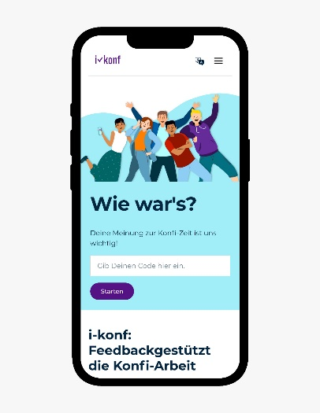

2) i-konf screen shot (Result display for the leader)

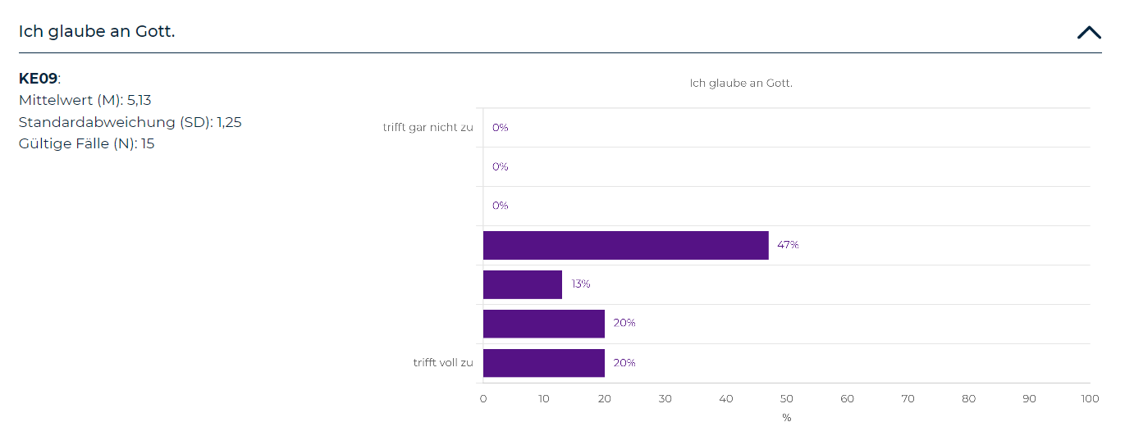

3) i-konf logo


